**Logical reasoning Test (set 2)**

**Company name: Mphasis No. of Question: 25**

**1:**

If > denotes +, < denotes –, + denotes ÷, ^ denotes ×, then 31 > 54 + 6 < 5 ^ 3 = ?

1. 16
2. 12
3. 25
4. 9

**Answer:** option c

**Solution:**

31 + 54 ÷ 6 – 5 × 3 = 40 – 15 = 25

**2:**

Find the mirror image of the figure given in the question figure out of the figures

given in the answer choices, when the mirror is placed horizontally on the line MN?

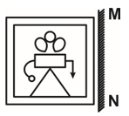

1. 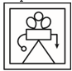
2. 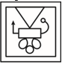
3. 
4. 

**Answer:** option d

**Solution:**



**3:**

Select a figure amongst the four alternatives, which when placed in question mark (?) of figure (X) would complete the pattern.

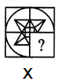

1. 
2. 
3. 
4. 

**Answer:** option b

**Solution:**

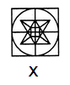

Option 2 satisfies the question mark in the problem figure(X).

**4:**

Find the missing number?

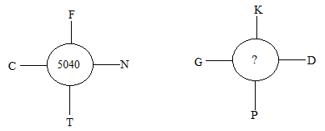

1. 2134
2. 6894
3. 3437
4. 4928

**Answer:** option d

**Solution:**

C(3) × F(6) × N(14) × T(20) = 5040

G(7) × K(11) × D(4) × P(16) = 4928

#SolutionHindi:

C(3) × F(6) × N(14) × T(20) = 5040

G(7) × K(11) × D(4) × P(16) = 4928

**5:**

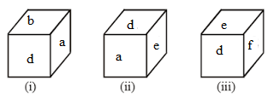

If ‘c’ is on the top of the dice then which side of the dice will come into the bottom side?

1. a
2. b
3. d
4. f

**Answer:** option c

**Solution:**

oppossite



**6:**

Pointing towards Sheena, Rahul said, “I am the only son of her mother’s son”. How is Sheena related to Rahul?

1. Cousin
2. Aunt
3. Sister
4. Wife

**Answer:** option b

**Solution:**

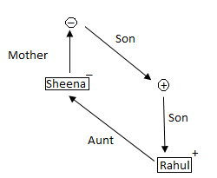

Hence, ‘Sheena’ is aunt of ‘Rahul’.

**7:**

Which one word can be formed by using these following letters?

I I I M O F N O T D A C

1. Alteration
2. Justification
3. Modification
4. Mobilization

**Answer:** option c

**Solution:**

Modification can only be formed by using ‘I I I M O F N O T D A C’.

**8:**

Select an alternative from figure (a), (b), (c) and (d) which contain symbols to exactly make the problem figure (X).

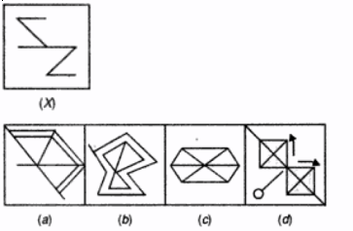

1. (a)
2. (b)
3. (c)
4. (d)

**Answer:** option d

**Solution:**

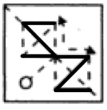

Figure (4) contains all the symbols of figure (X).

**9:**

How many triangles are there in the adjoining figure?

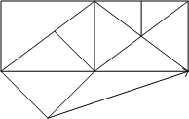

1. 21
2. 22
3. 17
4. 18

**Answer:** option d

**Solution:**

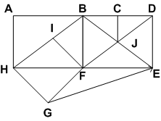  
The triangles composed are: ABH, HIF, FIB, HFB, HFG, BJF, DJE, BJD, JFE, BJC, DJC, BFD, BDE, DFE, EFB, EGH, EFG and HBE.

Thus, total number of triangles in the figure = 18.

**10:**

What will come at the place of question mark?

ID : 5 :: PD : ?

1. 14
2. 10
3. 12
4. 16

**Answer:** option c

**Solution:**

I = 9, D = 4, ID = 9 – 4 =5

D = 4, P = 16, DP = 16 – 4 =12

**11:**

Find the Second word according to the dictionary?

1. Tinkled
2. Tinned
3. Timber
4. Thunder

**Answer:** option c

**Solution:**

1) Thunder 2) Timber 3) Tinkled 4) Tinned

**12:**

Which of the two conclusions can be concluded on the basis of given statements?

**Statements:**

All desk are table.

All table are chair.

No table is mirror.

All pen are chair.

**Conclusion:**

Some pen being a desk is a possibility.

Some chair are not mirror.

1. Conclusion 1 is correct.
2. Either Conclusion 1or 2 is correct.
3. Conclusion 1 and 2 are both correct.
4. Conclusion 2 is correct.

**Answer:** option c

**Solution:**

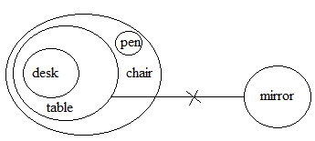

**13:**

Five friends P, Q, R, S, and T are sitting in a row and facing towards the north. P sits between T and Q whereas T sits the right to S. S and R sit at corners of the row. Who sits in the middle of the row?

1. P
2. Q
3. T
4. R

**Answer:** option a

**Solution:**



**14:**

Just like birds belong to the airplane. What is the fish related to it?

1. Fisherman
2. Boat
3. River
4. Fin

**Answer:** option b

**Solution:**

The airplane and birds fly in sky; similarly, fish and boat both float in water.

**15:**

In a certain code language, COULMN coded as 198327. So, find the code for COMMON?

1. 192297
2. 192298
3. 192997
4. 192397

**Answer:** option a

**Solution:**

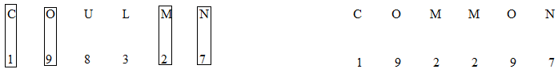

**16:**

Find the missing number?

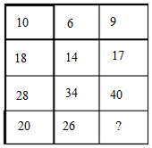

1. 10
2. 32
3. 42
4. 48

**Answer:** option b

**Solution:**

10 + 28 = 18 + 20 = 38

6 + 34 = 14 + 26 = 40

9 + 40 = 17 + 32 = 49

**17:**

A postman to reach Mr. Singh's house goes 7 km in the north. Then he turns left and move 4 km to reach Mr. Kumar's house. From there he turns right and moves for 3 km to reach Mr. Sharma's house. Find the distance between Sharma's house and Singh's house?

1. 3 km
2. 15 km
3. 5 km
4. 9 km

**Answer:** option c

**Solution:**

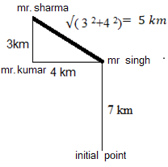

**18:**

Choose the term which is not like the other term in a group?

1. 5 - 12
2. 8 - 18
3. 10 - 24
4. 13 - 28

**Answer:** option c

**Solution:**

5 – 12 = 5 × 2 + 2

8 – 18 = 8 × 2 + 2

10 – 24 = 10 × 2 + 2 = 22 $≠$ 24

13 – 28 = 13 × 2 + 2 = 28

**19:**

Which of following diagram shows the correct relationship between Human, Men, and Actress?

1. 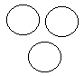
2. 
3. 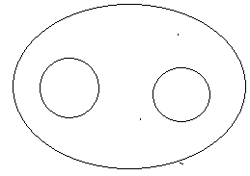
4. 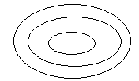

**Answer:** option c

**Solution:**

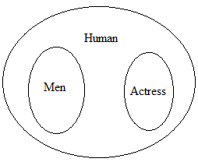

**20:**

In the following question, select the related word from the given alternatives?

Writer: ? :: Photographer: Camera?

1. Page
2. Pen
3. Book
4. Table

**Answer:** option b

**Solution:**

The photographer uses a camera to click photo, same as the writer uses a pen to write.

**21:**

In a certain code language MESSAGE is written as 49 so find the code for PROPERTY?

1. 67
2. 85
3. 81
4. 64

**Answer:** option d

**Solution:**

MESSAGE has 7 alphabets = 72 =49

PROPERTY has 8 alphabets = 82 = 64

**22:**

A word is represented by only one set of numbers as given in any one of the alternatives. The sets of numbers given in the alternatives are represented by two classes of alphabets as in two matrices given below. The columns and rows of Matrix I are numbered – from 0 to 4 and that Matrix II are numbered from 5 to 9. A letter from these matrices can be represented first by its row and next by its column, e.g., ‘U’ can be represented by 01, 14, etc. and E can be represented by 55, 66, etc. Similarly, you have to identify the set for the word ‘GROOM’.

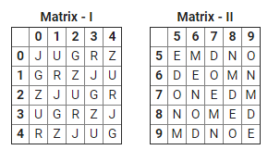

1. 13, 31, 96, 10, 11
2. 10, 32, 59, 86, 95
3. 42, 43, 65, 21, 82
4. 03, 59, 87, 88, 33

**Answer:** option b

**Solution:**

G = 10, R = 32, O = 59, O = 86, M = 95

**23:**

In the following question, four words are given, three of which are similar in some way, while the fourth is different. Choose the odd word.

1. Horse
2. Goat
3. Cat
4. Ox

**Answer:** option c

**Solution:**

All other vegetarian animals, while the cat is both vegetarian and non-vegetarian, therefore option (3) is correct.

**24:**

In the following question select the wrong number in the series from the given alternatives.

69632, 16408, 4352, 1088, 272, 68, 17

1. 68
2. 272
3. 1088
4. 16408

**Answer:** option d

**Solution:**

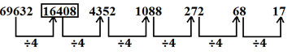

Wrong number = 16408.

And the correct number is =69632÷4=17408

Hence option (4) is correct.

**25:**

In the following question, four words are given, three of which are similar in some way, while the

fourth is different. Choose the odd word.

1. KQNN
2. DWFU
3. EVHS
4. HSKP

**Answer:** option b

**Solution:**

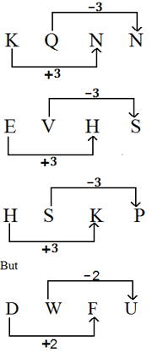

So, option (2) is the correct answer.